Problem 5

1. 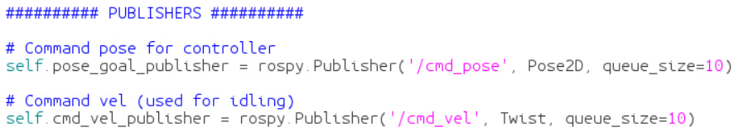subscriber.py publishes to the cmd_pose and cmd_vel topics. The message types are Pose2D and Twist respectively.
2. Done - coded but not tested
3. Done - coded but not tested
4. Done - coded but not tested